**Project Report**

**BUS 235C: Data Mining**

**Stock Price Prediction**San Jose State University  
Master of Science in Data Analytics



**Group 5**

Aarathi Nadathur - 013704405  
Amar Ippili - 013728975

Divya Puraswani - 013755391

Sameer Rajput - 013802841

Shubh Johri - 013750672

Table of Contents

Project Description 6

**1.1 Project Introduction 6**

**1.2 Problem Statement 7**

**1.3 Project Objectives and Goal 7**

**1.4 Project Challenges 8**

Requirement Analysis 9

**2.1 Feasibility Study 9**

**2.2 Requirements Specification 10**

Project Management 12

**3.1 Project Organization 13**

**4.2 Project Schedule 13**

Project Design 15

**4.1 System Design and Implementation 15**

**4.2 Knowledge Discovery in Database 15**

**4.3 Use Case Diagram 18**

**4.4 High Level Architecture 20**

**4.5 Data Flow Diagram 21**

**4.6 Entity Relationship Diagram 23**

Project Implementation/ Methodology 24

**5.1 Data Science Algorithms used: 24**

**5.2 Feature/Data Engineering 27**

**Normalizing Dataset: 30**

**Train-test split: 32**

Model Evaluation/ Testing 33

Project Interface/ Client-Side Design 35

Server-Side Design 39

Model Deployment 41

Active Learning/ Feedback Loop 43

**9.1 Technical Skills 43**

**9.2 Behavioral skills 44**

**High Performance Computing (HPC) 45**

**Google Cloud Platform 45**

**Design patterns 46**

Bibliography 47

**Table of Figures**

**Figure 1: Data Science Life Cycle 12**

**Figure 2: Project Organization 13**

**Figure 3: PERT chart 14**

**Figure 4: System Design and Workflow 15**

**Figure 5:Knowledge Discovery in Databases 16**

**Figure 6: Use Case Diagram 18**

**Figure 7: High Level Architecture 20**

**Figure 8:Dataflow Diagram 22**

**Figure 9: ER Diagram 23**

**Figure 10: Working of LSTM on data 26**

**Figure 11: Descriptive statistics of data 28**

**Figure 12: Closing Price of MSFT over a period of time 29**

**Figure 13: Opening Price of MSFT over a period of time 29**

**Figure 14: Volume of MSFT over a period of time 30**

**Figure 15: Normalized data 31**

**Figure 16: Closing Price of MSFT Normalized data 31**

**Figure 17: X_train, X_test, y_train, y_test shape 32**

**Figure 18: Predicted values vs Actual values 33**

**Figure 19: Train-Test RMSE scores 34**

**Figure 20: Chatbot interacting with user using ticker symbol 35**

**Figure 21:Chatbot Features and viewing historical data of stock 36**

**Figure 22: Chatbot displaying Investor sentiments and Predicted future closing price 36**

**Figure 23: Chatbot displaying Comparison of stocks 37**

**Figure 24: Comparison of two stocks 37**

**Figure 25: Predicting the future closing price of stock 38**

**Figure 26: Graph showing the historical data 38**

**Figure 27: Server side 39**

**Figure 28: URL 41**

**Figure 29: Data Flow between user and server space 42**

**Figure 30: Model data flow 42**

**Figure 31: High Performance computing technologies 45**

**Table of Tables**

**Table 1: Use Case Index 18**

**Table 2: Parameters in dataset 23**

**Table 3: Learning Resources 39**

**Chapter 1**

# **Project Description**

## **Project Introduction**

Being one of the most important factors in the growth of economy, stock market is a place where people buy and sell stock of the companies listed publicly. It indicates how well the companies listed are doing. Stock market prediction involves determining the future value of the company listed. It is said that there is a direct relationship with the demand and supply of company’s stock and its price [1]. Several factors are directly or indirectly responsible for fluctuations in price. This results in defining stock market as a volatile market involving risk of return over investment. Keeping investors, traders and industry as the key stakeholders, price of stock is predicted such that profits can be earned over investment.

Data is just like a dense forest, the more you throw light on it, the better you can discover the path. This light of applying data mining techniques to discover the path of insights has benefitted almost every industry today. Applications such as Fraud detection, Automating Risk Analysis etc. in financial industry have helped investors, traders and financial institutions. Predictive analytics is predicting future outcomes based on historical data such as weather forecasting. Predicting Stock Market is one such daunting task whose implementation is made easy by using Machine Learning Algorithms and Artificial Intelligence. Natural Language Processing techniques has made text, emotion understanding easy. Sentiment analysis is one such field which can help in predicting emotions of investors towards stock to go up or down i.e. its movement. Modeling of data using traditional models such as ARIMA and deep learning models such as LSTM help in time series analysis. It helps in predicting future values depending on the past trends or patterns [2].

## **Problem Statement**

Stock market is unpredictable, thus, requires a close watch on its happenings. Deciding which stocks to buy or which stocks to sell becomes difficult for the investors. Predicting the future closing price of a stock based on its historical data can help them drive decision. The prediction can be done using Long Short-Term Memory (LSTM) which can be applied on large historical data collected within a timeframe of 19 years.

## **Project Objectives and Goal**

The objective of the project- Trading and Investment Newbie Assistant (TINA) is to help investors with the following features:

* Get Investors sentiments from American Association of Individual Investors
* Get Stock sentiments from top 200 tweets from Twitter based on ticker.
* View features of stock for current day.
* View Comparison of two stocks
* Predict future close price of stock

The goal of the project is to understand and implement data mining techniques such that stakeholders be benefitted by getting the closely predicted closing price of a stock. It will help in taking better decisions for buying and selling stocks.

## **Project Challenges**

The challenge of the project is to accurately predict the price, as stock markets are subject to market risk and involve substantial amount of risk. The prediction for future is based on past events but future of stock market is uncertain. Though model may perform better but uncertain event may lead to fallacious predictions.

**Chapter 2**

# **Requirement Analysis**

## **2.1 Feasibility Study**

An important outcome of the preliminary investigation is the determination that the system requested is feasible. Feasibility study examines how beneficial is the project economically, technically and non- technically i.e. under three aspects –

* Economic Feasibility
* Technical Feasibility
* Operational Feasibility

**Economic Feasibility-** The economic analysis of the project counts for the cost effectiveness of the project. The analysts raise various questions related to finance during preliminary investigation to estimate the cost involved in building the system. Trading and Investment Newbie Assistant (TINA) can be regarded as economically feasible as internet and computer system is available to the user. Hence, there is no need of bearing cost on additional resources. The only cost involved in the project is the deployment of model on cloud. These costs are quite minimal and affordable for user.

**Technical Feasibility-** The technical analysis of the project counts for the software technology, available personnel and the likelihood of the project to be built in new technology for upgradation. In our project the technical feasibility is considered by using Python language. It has a rich collection of libraries which are used for data extraction, manipulation, modelling and interpretation. Thus, the problem of non-availability of software eradicates. Proposed system can be expanded in future if required. The system has the capacity to hold the data of the firm.

**Operational Feasibility-** Operational feasibility is also known as Behavioral feasibility, as it measures the behavior of users i.e. how efficiently the system is used by users. The system is behaviorally feasible as it fulfills the following points:

* Trading and Investment Newbie Assistant (TINA) is easy to operate.
* Retrieval of information is easy, fairly accurate and fast.
* Searching is easy.
* The system can work online.

## **2.2 Requirements Specification**

One of the important aspects of Project Management is Requirement Analysis. The functional and non-functional requirements of the system which describes the user’s interaction with the system are:

**Functional Requirements-** It describes the components of system, set of inputs, behavior and output. The bot allows investor to view-

* Investors sentiments from American Association of Individual Investors

**Input-** Ticker symbol of the company

**Output-** Sentiments calculated as Bullish, Bearish and Neutral

* Stock sentiments from top 200 tweets from Twitter based on ticker

**Input-** Ticker symbol of the company

**Output-** Sentiments calculated as Positive, Negative and Neutral

* View features of stock for current day

**Input-** Ticker symbol of the company

**Output-** Open, High, Low, Close, Volume values for a stock are displayed

* Comparison of two stocks

**Input-** Ticker symbols of two different companies

**Output-** Graphical comparison of the values

* Predict future close price

**Input-** Ticker symbol of the company

**Output-** Predicted value of the closing price of the stock for next day

**Non-functional Requirements-** The qualities of the system are:

* **Usability-** The users get response within seconds which can save a lot of time and effort.
* **Interface-** The Interface designed aims at providing a flexible front-end communication to the user such that clear information is available while navigating the system.
* **Supportability and Portability-** The system designed is supportable cross-platform.

#### **Technical Requirements- Hardware Requirements**

Processor: 2.2 GHz Intel Core i7

Hard Disk: 256 GB

RAM: 16 GB

#### **Software Requirements**

Operating System: Windows/Mac

Python Notebook/IDE: Google Collaboratory Environment and Jupyter Notebook

Python Libraries: Keras, SciKit-Learn, NumPy, Matplotlib, Pandas, SciPy, Python

LSTM model is implemented using Keras and other libraries for data preprocessing.

**Chapter 3**

# **Project Management**

To understand the exact goals of the project, how can they be achieved by managing people (Project Organization), resources (Resource Requirements), timelines (Project Schedule) and applying knowledge, tools and skills is the practice of Project Management. The Data Science life cycle is illustrated in Figure 1 [3]:

|  |  |  |
| --- | --- | --- |
| **Data Science Life Cycle** | | |
| **Task** | **Subtasks** | **Stakeholders/People involved** |
| Understanding Problem | 1. Determining Objective, Scope, Requirements | Business, Data Engineer, Data Scientist, Data Analyst |
| 1. Assessing Success Criteria and constraints | Business, Data Scientist, Data Engineer, Data Analyst |
| Data Understanding | 1. Obtaining, Assessing, Exploring and filtering Data | Data Engineer, Data Analyst, Data Scientist |
| Data Preparation | 1. Cleaning, Filtering and Feature Engineering | Data Engineer, Data Scientist, Data Analyst, Machine Learning Engineer |
| Data Modelling | 1. Selecting Model Approach, Building Models, Selecting Model | Machine Learning Engineer, Data Scientist, Data Engineer |
| Evaluation of Results | 1. Validating, Explaining and Deploying Model | Machine Learning Engineer, Business, Data Scientist, Data Analyst |
| Model Deployment | 1. Deploying model, Monitoring and maintaining, Terminating | IT Operations, Data Analyst, Business, Data Scientist, Data Analyst |

Figure 1: Data Science Life Cycle

## **3.1 Project Organization**

A Project Organization is a structure defining the team hierarchy, identifying roles and responsibilities at each position. The team structure is shown in Figure 2:

Project Committee

Dr.Chandrasekar Vuppalapati Technical Advisor

Project Team Members

Ippili, Amar MSDA Graduate Student

Johri, Shubh MSDA Graduate Student

Nadathur, Aarathi MSDA Graduate Student

Puraswani, Divya MSDA Graduate Student

Rajput, Sameer MSDA Graduate Student

Figure 2: Project Organization

## **Project Schedule**

Project Schedule refers to the listing of tasks, deliverables and milestones within the project including its planned start and finish date.

**PERT** is an acronym for Program Evaluation Review Technique. It is a project planning tool which helps in scheduling tasks and coordinating with team members which helps in accomplishment of work. It helps in knowing the estimated amount of time to finish a realistic project [4].

We have listed our tasks and deliverables using a PERT chart as shown in Figure 3:

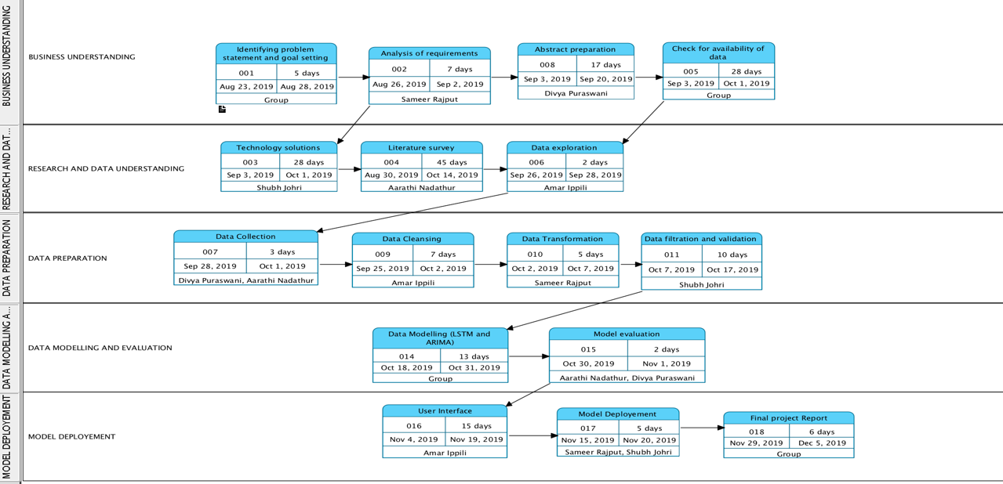

Figure 3: PERT chart

**Chapter 4**

# **Project Design**

## **4.1 System Design and Implementation**

The historical data collected from Yahoo Finance using Pandas data reader is cleaned, normalized and split into training and test dataset such that ARIMA and LSTM model can be performed on it. Result is the predicted value of closing price for next day which is demoralized to get the price value in required format. Root Mean Squared Error (RMSE) is used for measuring accuracy. Chatbot trained using neural network is connected with flask to provide graphical user interface to user.

The system design and workflow are illustrated in Figure 4:

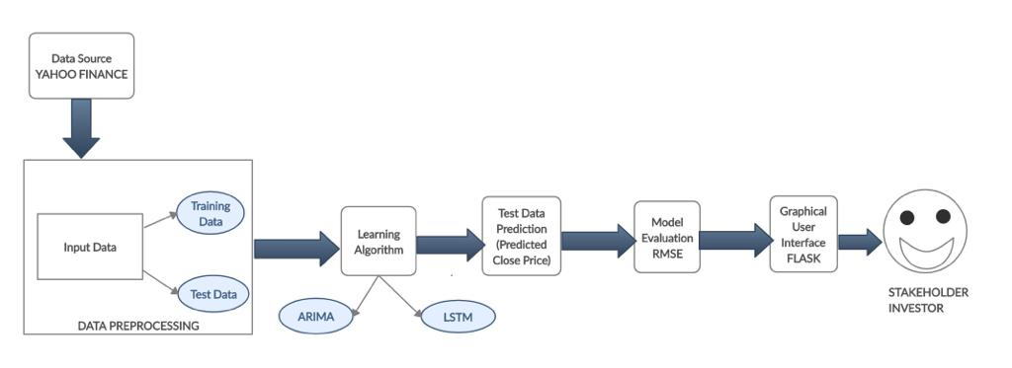

Figure 4: System Design and Workflow

## **4.2 Knowledge Discovery in Database**

Being iterative and interactive process, Knowledge Discovery in Databases (KDD) is the organized process of identifying valid, novel, useful, and understandable patterns from large and complex datasets [5]. The Knowledge Discovery in Databases (KDD) for Trading and Investment Newbie Assistant (TINA) is illustrated in Figure 5:

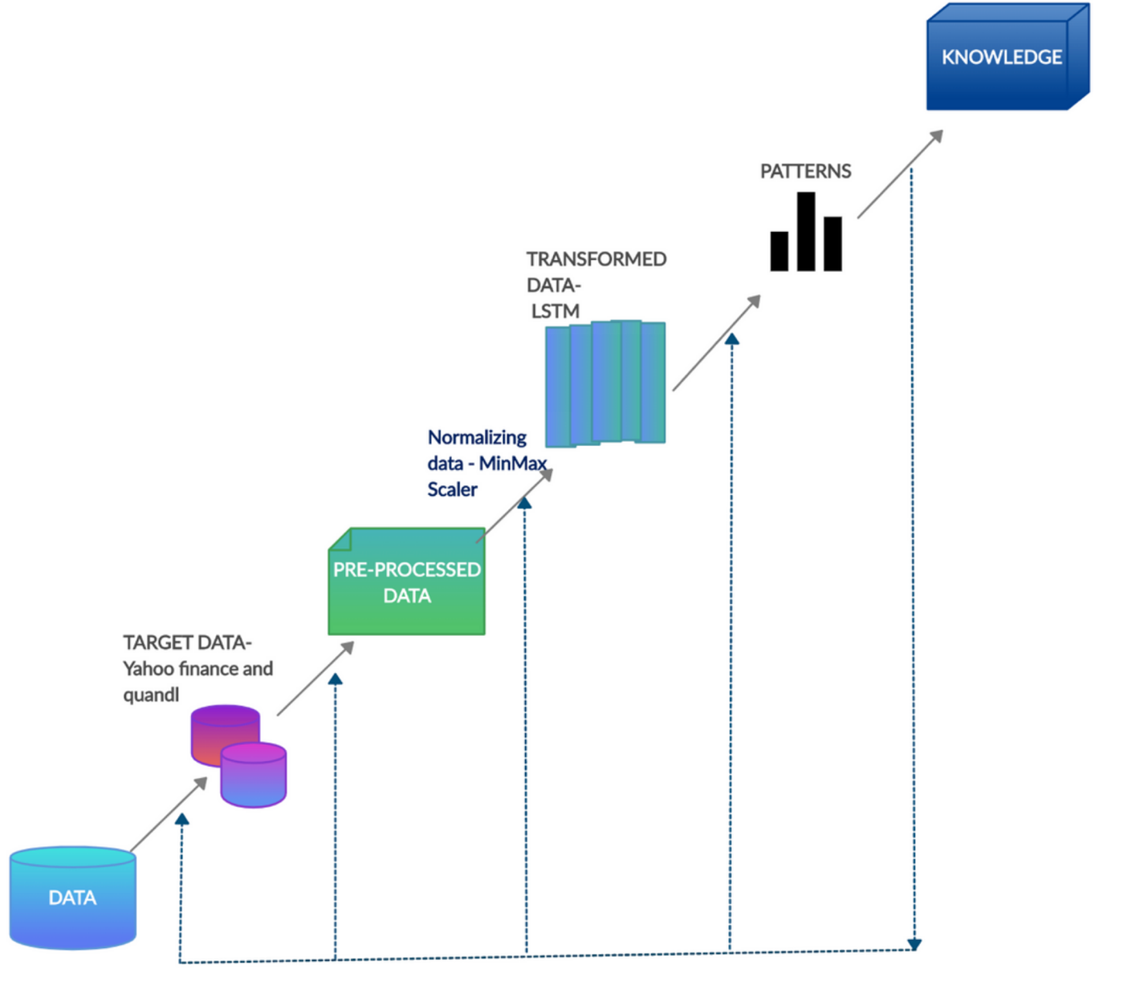

Figure 5:Knowledge Discovery in Databases

The steps in Knowledge Discovery in Databases (KDD) are described as below:

1. **Developing an understanding of application domain**: After understanding the need of stock market prediction in the financial domain, we designed a chatbot which can communicate with user using data mining algorithms.
2. **Selecting the dataset**: There are several data sources such as Quandl, Google finance, Yahoo finance etc. in order to fulfill the end user’s requirement of getting the predicted future closing price. Historical data was taken from Yahoo finance using pandas datareader library. The data was collected from January 01, 2000 to December 01, 2019. To get the sentiments, data was taken from Quandl.
3. **Data Cleaning and Preprocessing**: Data cleaning involves handling missing values if any, removing noise or outliers. The data retrieved did not have null values nor outliers. It was sorted on Date column such that latest date of information retrieved can be first. Using pandas, the descriptive statistics and dtypes of the data is explored. Irrelevant columns such as High, Low are removed from the dataset.
4. **Data Transformation**: Data is transformed using MinMax Scalar function. This estimator scales and translates each feature individually such that it is in the given range on the training set, e.g. between zero and one [6].
5. **Selecting suitable Data Mining Task**: Prediction and Description are the two major goals of data mining. Stock Market Price Prediction is an important task of financial time series forecasting. [7] Machine learning methods used for time series problems are Autoregressive Integrated Moving Average (ARIMA), Vector Autoregression (VAR), Simple Exponential Smoothing (SES), Recurrent Neural Networks (RNN).
6. **Selecting the Data Mining algorithm**: The chatbot is trained on neural network. For predicting price Long Short-Term Memory (LSTM) is used. The use of Autoregressive Integrated Moving Average (ARIMA) is also done to compare the traditional and deep learning models.
7. **Model Implementation**: The selected Long Short-Term Memory (LSTM) and Autoregressive Integrated Moving Average (ARIMA) are applied to the dataset with setting parameters as: batch size=100, prediction time=1, no of epochs=5, ratio of training and test data was 82% and 17% respecting, unroll=50.
8. **Model Evaluation**: The accuracy is measured using Root Mean Squared values (RMSE). The lower is the value of RMSE i.e. towards zero, better is the model.
9. **Getting insights**: After implementing the algorithm the future closing price of the stock is predicted, sentiments as positive, negative and neutral are calculated from top 200 tweets collected using tweepy api.

## **4.3 Use Case Diagram**

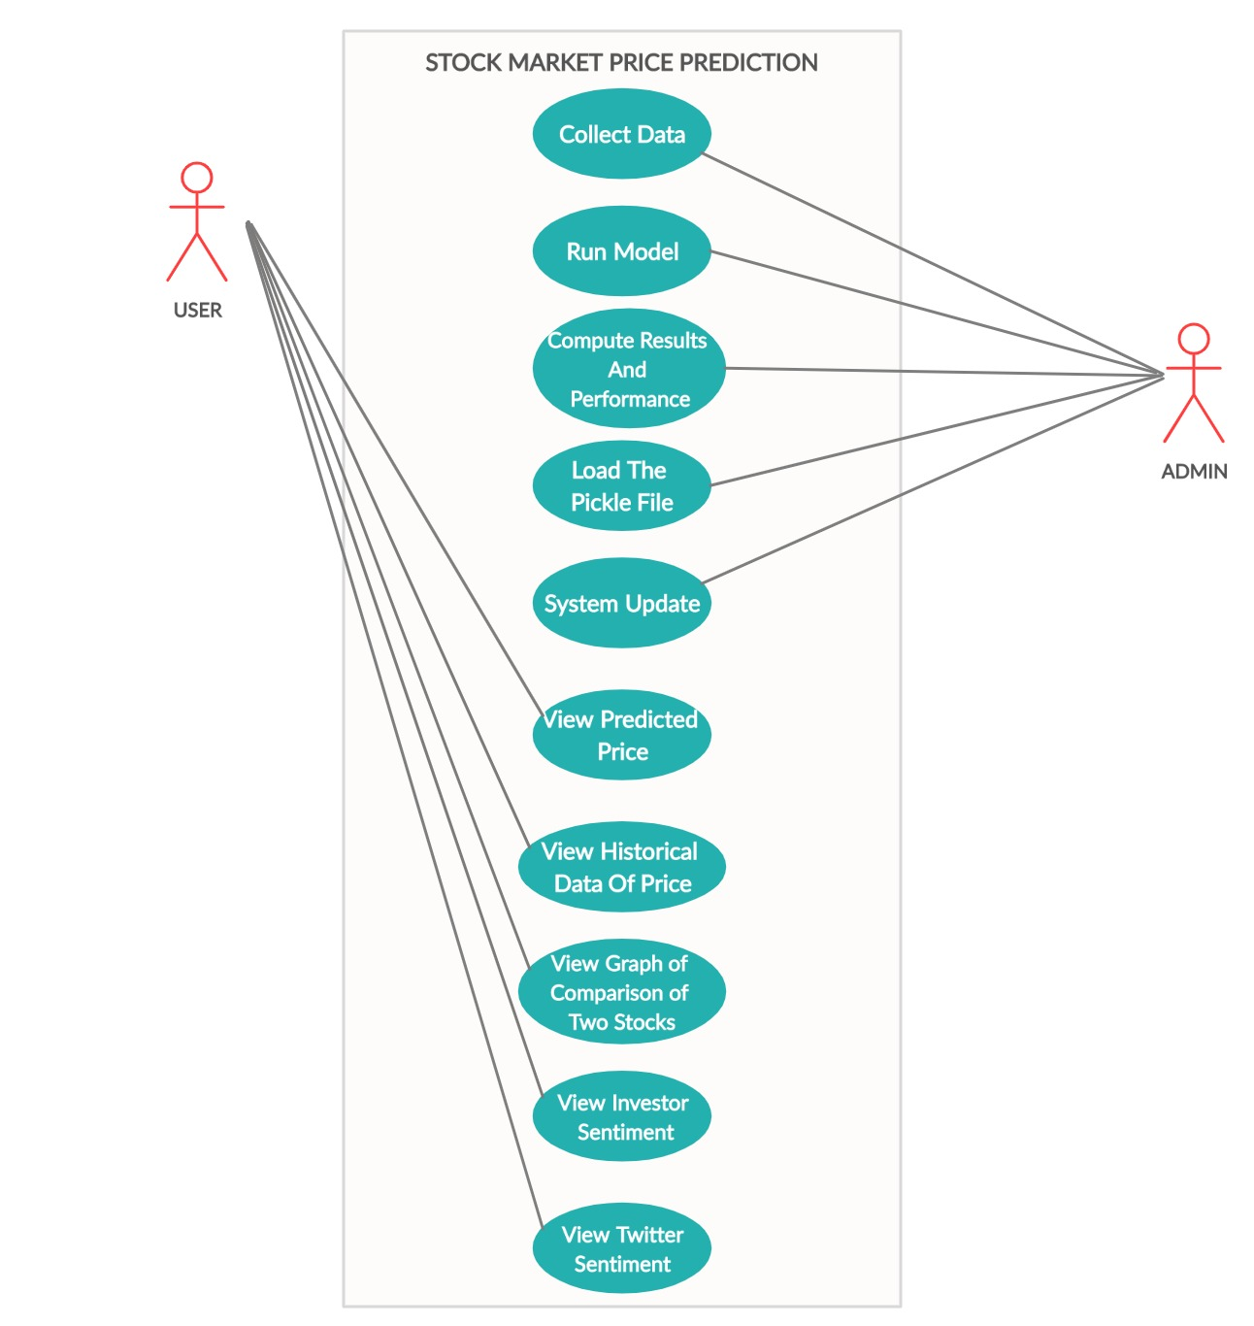

Figure 6: Use Case Diagram

Use Case Diagram as shown in Figure 6 specifies the expected behavior (what), and not the exact method of making it happen (how). A key concept of use case modeling is that it helps us design a system from the end user's perspective. It is an effective technique for communicating system behavior in the user's terms by specifying all externally visible system behavior [8]. The use case index is shown as in Table 1 below:

|  |  |  |  |  |  |
| --- | --- | --- | --- | --- | --- |
| **Use Case ID** | **Use Case Name** | **Primary Actor** | **Scope** | **Complexity** | **Priority** |
| 1 | Collect Data | admin | in | high | 1 |
| 2 | Run Model | admin | in | high | 1 |
| 3 | Compute results and Performance | admin | in | high | 1 |
| 4 | Load the Pickle file/ Save Model | admin | in | high | 1 |
| 5 | System update | admin | in | high | 1 |
| 6 | View Predicted Price | user | in | high | 1 |
| 7 | View historical data related to price of stock | user | in | medium | 2 |
| 8 | View Graph of Comparison of two stocks | user | in | medium | 2 |
| 9 | View Investor sentiment | user | in | high | 1 |
| 10 | View Twitter Sentiment | User | in | high | 1 |

Table 1: Use Case Index

In Table 1 the, Scope refers to the extent of what is designed by us as against already existing design. If the job is within the scope of discussions that is related to functional or design scope ‘in’ is used else ‘out’ [9].

Priority refers to the number assigned to the task as per importance.

## **4.4 High Level Architecture**

Figure 7 shows high level architecture depicting the data sources, cleansing, modelling, evaluation steps followed:

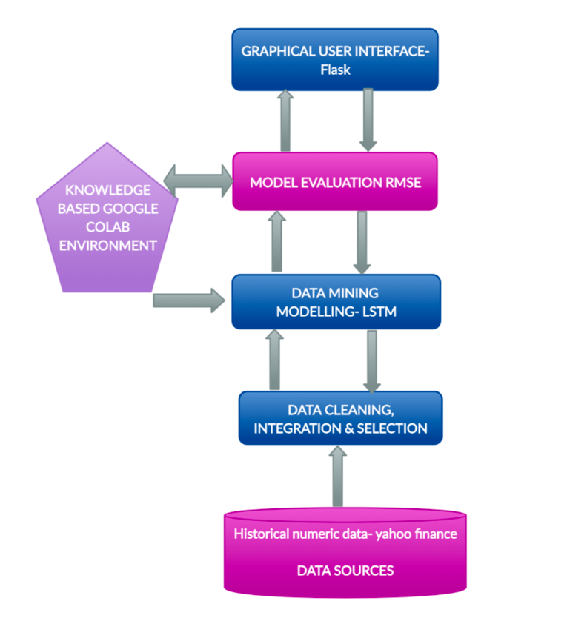

Figure 7: High Level Architecture

The explanation for Figure 7 is as below:

* **Data Sources:** Various sources of data are available. Data is collected from Yahoo finance for Microsoft (MSFT), Cisco (CSCO), IBM, Starbucks (SBUX).
* **Data Cleaning, Integration and Selection:** It involves selecting important features, reversing the data, visualizing data and predicting the closing price of stock for the next day.
* **Data Mining Modelling:** Traditional and Deep Learning models are used for time series forecasting. We used ARIMA and LSTM model for data modelling.
* **Model Evaluation:** The metrics used for model evaluation are Mean Squared Error (MSE) and Root Mean Square Error (RMSE) for continuous variables.
* **Graphical User Interface:** Flask is a web framework. This means flask provides you with tools, libraries and technologies that allow you to build a web application. This web application can be some web pages, a blog, a wiki or go as big as a web-based calendar application or a commercial website. Flask is part of the categories of the micro-framework. Micro-framework is normally framework with little to no dependencies to external libraries. This has pros and cons. Pros would be that the framework is light, there are little dependency to update and watch for security bugs, cons is that some time you will have to do more work by yourself or increase yourself the list of dependencies by adding plugins [10].

## **4.5 Data Flow Diagram**

A level 0 data flow diagram (DFD), or context diagram, represents a data system as a whole and depicts the way it interacts with external entities. This DFD level 0 example shows how such a system might function within a business. In our DFD we have shown how stock price prediction system focusing mainly on the business requirements. The StockBot- TINA, interacts with the user and the user can know the close price, the stock info(sentiment), comparison between stocks etc. The data for stock sentiment is taken from the twitter API and for the prediction of the close price it is taken from yahoo finance. The data from yahoo finance is preprocessed and necessary feature engineering is performed, then using machine learning models such as LSTM and ARIMA the prices are predicted for the next day. The model is evaluated based on MSE and RMSE scores. The integration of the machine learning model with the stockbot is done using flask.

The diagram is shown in figure 8.

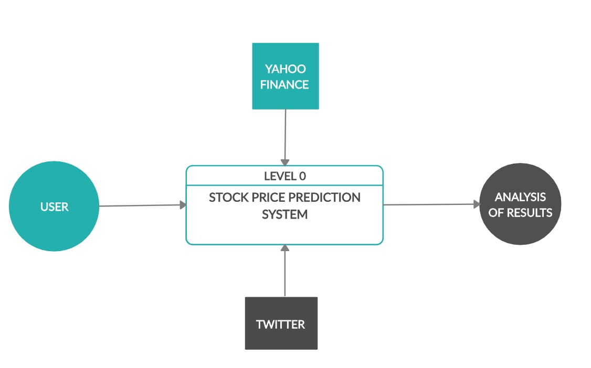

Figure 8:Dataflow Diagram

## **4.6 Entity Relationship Diagram**

The ER diagram for trading and investment newbie assistant (TINA) is shown in figure 9.

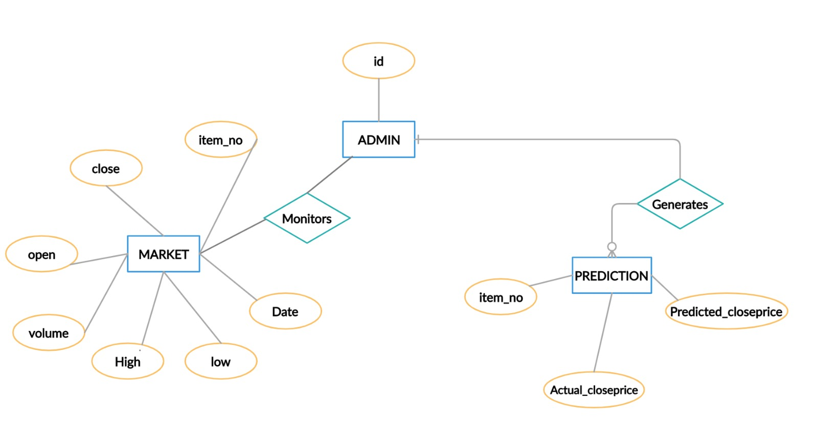

Figure 9: ER Diagram

**Chapter 5**

# **Project Implementation/ Methodology**

## **5.1 Data Science Algorithms used:**

**ARIMA Model**

ARIMA is an acronym that stands for AutoRegressive Integrated Moving Average (AR- AutoRegressor**,** I-Integrated**,** MA- Moving Averages). An ARIMA model might be a classification of applied math models for analyzing and prognostication statistic knowledge. It explicitly takes into account a lot of standard structures in time series information, and itself gives a simple and powerful strategy for making skillful statistics estimates.

ARIMA model can be clarified by illustrating every one of its parts as pursues:

*AR (Autoregression):* A model that uses the dependency be- tween observation and some number of slacked observations.

*I (Integrated):* The utilization of differencing observations so as to make the time series stationary.

*MA (Moving Average):* A model uses the reliance between a perception and a residual error from a moving average model applied to slack observations. Standard documentation used in ARIMA, **ARIMA(p,d,q);** where the parameters are substituted with whole number qualities to rapidly demonstrate the particular ARIMA model. The parameters of the ARIMA model are characterized as follows:

p: The quantity of slack perceptions remembered for the model, likewise, called the slack order.

d: The occasions that the raw samples are differenced, additionally called the level of differencing.

q: The size of the moving average window likewise called the order of the moving average.

The forecasting equation is constructed as follows. First, let y denote the dth difference of Y, which means: In terms of y, the general forecasting equation is:

yˆt =μ+θ1yt−1 +… +pyt−p −1et−1 −…−qet−q

ARIMA models have demonstrated an effective ability to produce short-term forecasts. It continually beats complex basic models in the short-term prediction. The steps in building the ARIMA predictive model comprise of the model identification, parameter estimation, and diagnostic checking. It is used on stationary time series data. Stationary time series data means that the mean, variance and the autocorrelation are constant over time [11].

**LSTM Model**

Long Short-Term Memory networks are a category of RNN, that has the capability for learning long-term dependencies. LSTMs are specially designed to avoid the long-term dependency problem, Storing and memorizing information for long periods of time by default. The model has the ability to remove or add information, carefully regulated by structures called gates. Gates are a way to freely let information through. These consist of a linear neural net layer and a pointwise multiplication operation.

The component is regulated using the linear function output, which ranges between 0 and 1. The input gate determines how much emphasis to put on each of the inputs, the forget gate determines the information that is to be removed, and the output gate determines the final ht based on the intermediate states.

LSTMs can be used to model univariate time series fore- casting problems. These are problems comprised of a single series of observations and a model is required to learn from the series of past observations to predict the next value in the sequence [12].

Figure 10, reflects that data colored in green (Samples 0 to 2) is one set of input which predicts the next value of Close price as output in green solid color (Sample 3). The samples 1 to 3 would be our second input and Close price of sample 4 would be output value; represented by blue rectangle. And so on. Then input-output pair 1 (green rectangle) and pair 2 (blue rectangle) would constitute batch one [13].

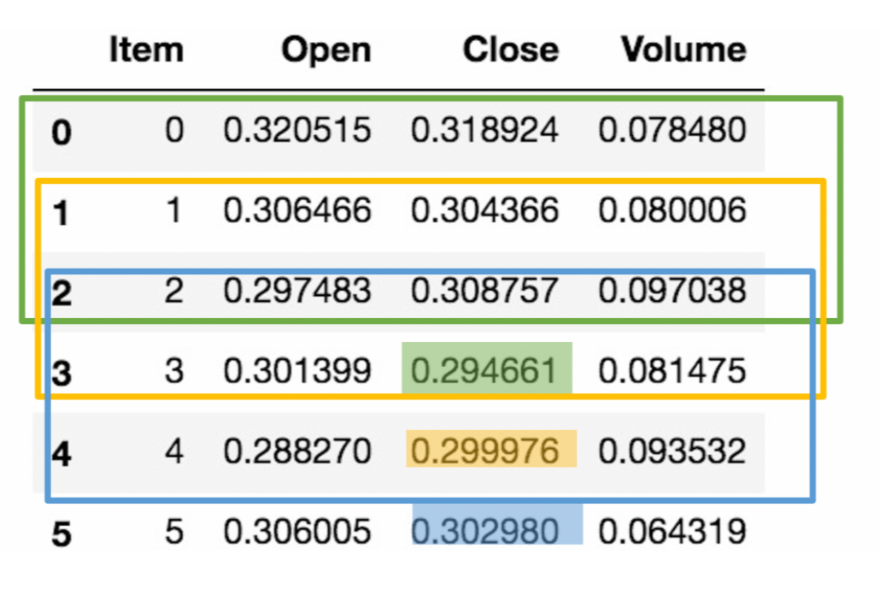

Figure 10: Working of LSTM on data

**ARIMA vs LSTM**

* ARIMA yields better results in forecasting short term, whereas LSTM yields better results for long term modeling.
* ARIMA requires a series of parameters (p,q,d) which must be calculated based on data, while LSTM does not require setting such parameters. However, there are some hyperparameters we need to tune for LSTM.
* ARIMA models are linear and LSTM models are nonlinear

## **5.2 Feature/Data Engineering**

The historical stock data from January 01, 2000 to December 01, 2019 of Microsoft (MSFT) has been collected from the yahoo finance website using Pandas datareader stored in a dataframe. The dataframe is than converted to .csv format such that it can be shareable. The dataset has the following features as shown in Table 2:

|  |  |
| --- | --- |
| **Feature** | **Description** |
| Date | Date of trade |
| Open | Opening price of stock on particular day |
| High | The highest price that a stock has reached in a day. |
| Low | Lowest price of a stock on that day. |
| Close | Price of the stock at close(end)of the day. |
| Volume | Number of shares traded |

Table 2: Parameters in dataset

On using. describe () the descriptive statistics can be visualized as in Figure 8.

From the Figure 11, we see that the column Volume is important as it states the number of transactions. Higher the price, lower the volume is a sign of risk. While columns date, high and low are unimportant features and are not required for predicting the close prices of the stock as high states the highest price of stock for a particular day and low states the lowest trading price of a stock in a day. Opening and closing prices of stock matters which are used. Profit is expected if closing price is higher than opening price and loss if vice-versa. So, we dropped those columns and then reverse the order of dataset so that the latest stock data appears first.

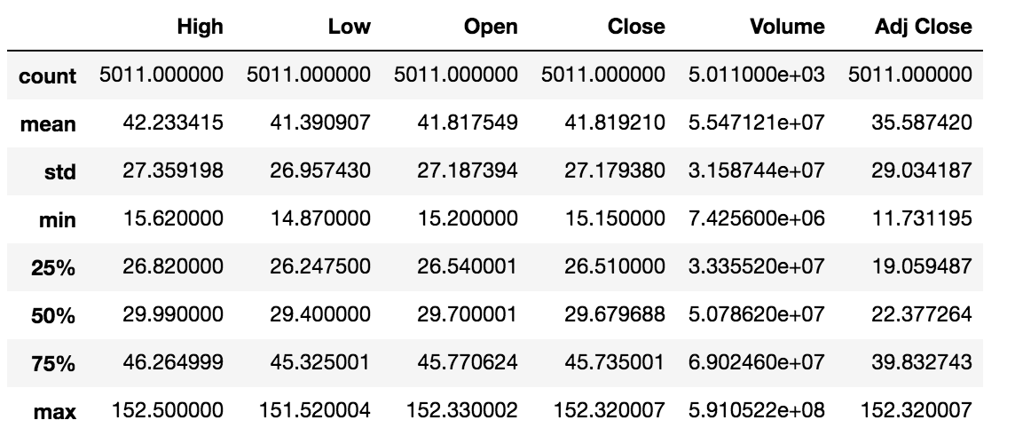

Figure 11: Descriptive statistics of data

After features being selected using visualization representation is done as shown in Figure 12 and Figure 13. Visualizations help in identifying trends and patterns which helps in enabling decisions.

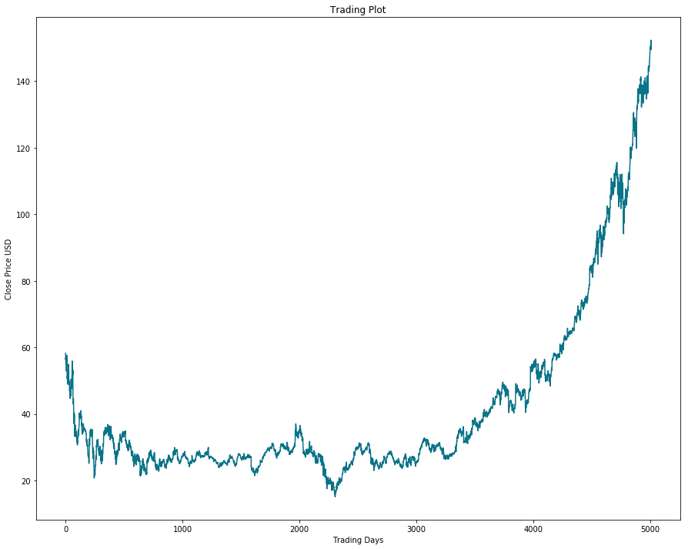

Figure 12: Closing Price of MSFT over a period of time

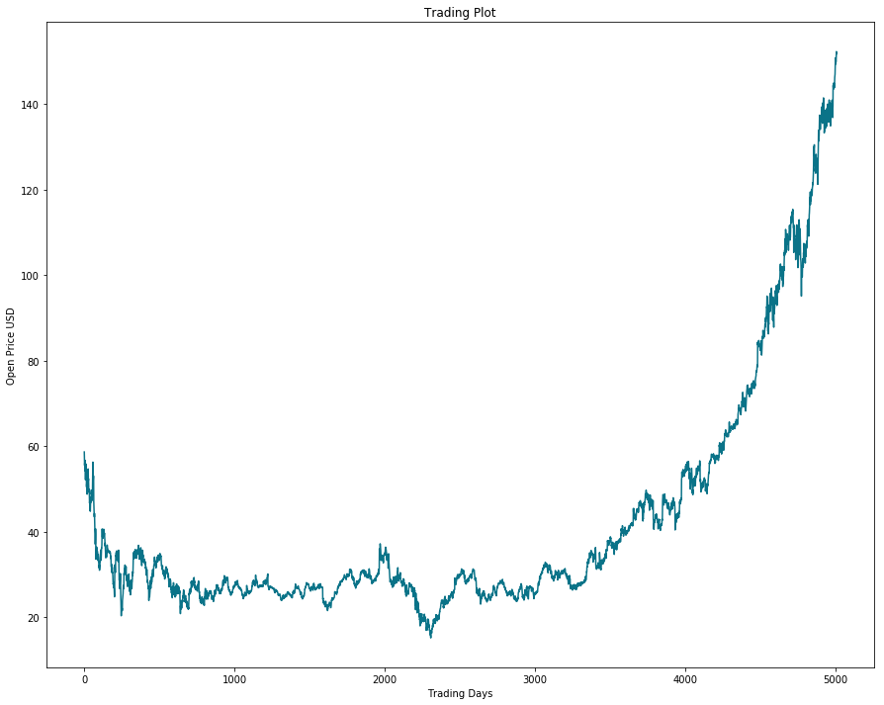

Figure 13: Opening Price of MSFT over a period of time

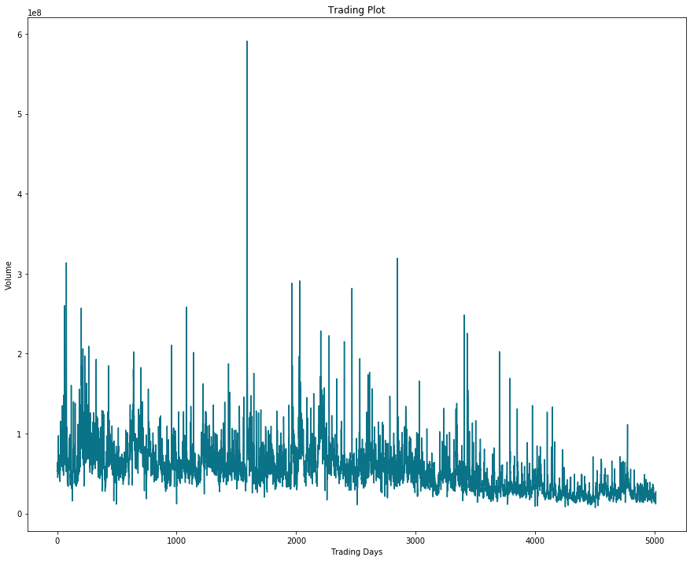

Figure 14: Volume of MSFT over a period of time

### **Normalizing Dataset:**

Normalizing the data using minmax scaler function. In minmax scaler function, the minimum value in the features is subtracted and then divided by the range (Maximum value -Minimum value). The data after being normalized using the minmax scaler will range between 0 and 1.

The normalized data is shown as in Figure 15:

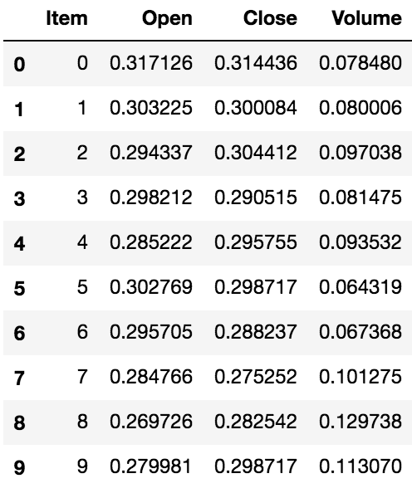

Figure 15: Normalized data

Visualizing the graphs using normalized data as in Figure 16. The graph looks smooth as compared to the graph in Figure 12.

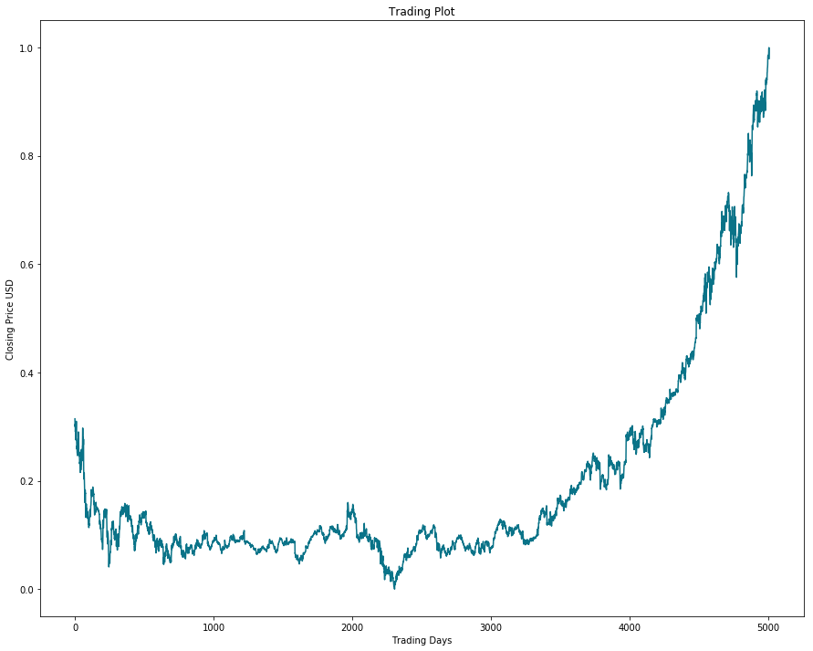

Figure 16: Closing Price of MSFT Normalized data

**Train-test split:**

We split the data into training and test dataset in the ratio (82.95: 17.05). The shape of the data after the split is as shown in Figure 17:

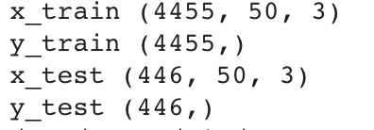

Figure 17: X_train, X_test, y_train, y_test shape

On Building LSTM Model following parameters were considered:

Epochs = 5

Batch size= 100

Number of layers= 3

Dropout= 0.2

Validation split= 0.05

Activation function= Linear

Unroll length= 50

Unrolling is a mechanism which occupies more memory and makes it run LSTM’s faster.

The Model performed well and resulted into close predicted desired results. However, they cannot be said accurate as stock markets are subject to market and involve substantial amount of risk.

**Chapter 6**

# **Model Evaluation/ Testing**

Plotting the predicted and actual values resulted in understanding the performance of the model. The Figure 18 represents a better predicted graph:

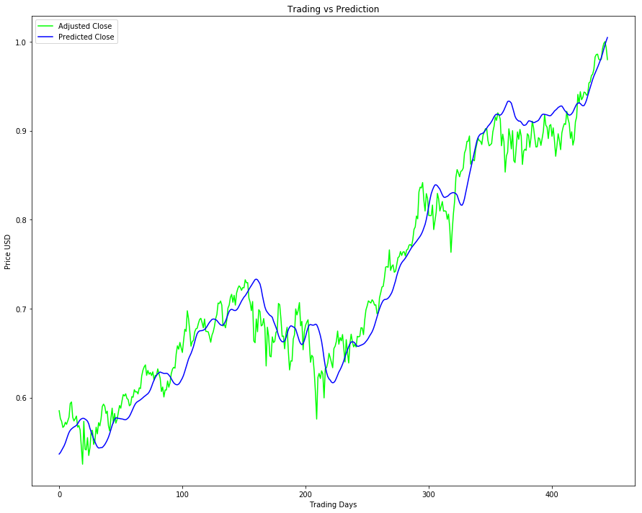

Figure 18: Predicted values vs Actual values

Calculating Root Mean Square Error (RMSE) also helped in evaluating the performance of the model. The Figure 19 below shows the better performance as value is smaller and closer to 0.

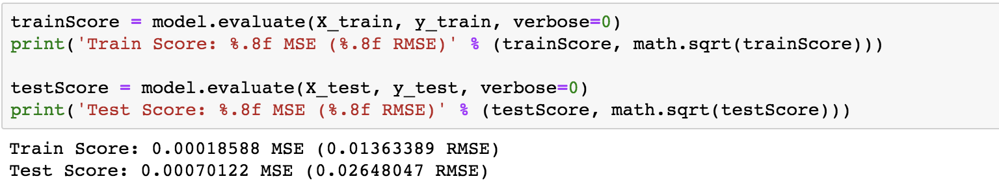

Figure 19: Train-Test RMSE scores

**Chapter 7**

# **Project Interface/ Client-Side Design**

**ChatBot:** A chatbot is a piece of software that conducts a conversation via auditory or textual methods. Such programs are often designed to convincingly simulate how a human would behave as a conversational partner.

Our chatbot is related to Stock Trading, so we have trained the chatbot using different patterns of Questions related to stock trading. Here each pattern corresponds to a defined intent type (class).

We first converted all the patterns to vectors using bag of words and then trained a Neural Network using these vectors with target variable as the Intent Type.

After the Network is trained if you want to predict an intent of the input, again the input is converted to vector using bag of words and the vector is passed to a Neural Network which outputs a list of probabilities each corresponding intent. The intent with the highest probability is the class predicted for the given input and the response for the class is generated and passed back to user.

The interface is shown as in Figure 20 – Figure 26, below:

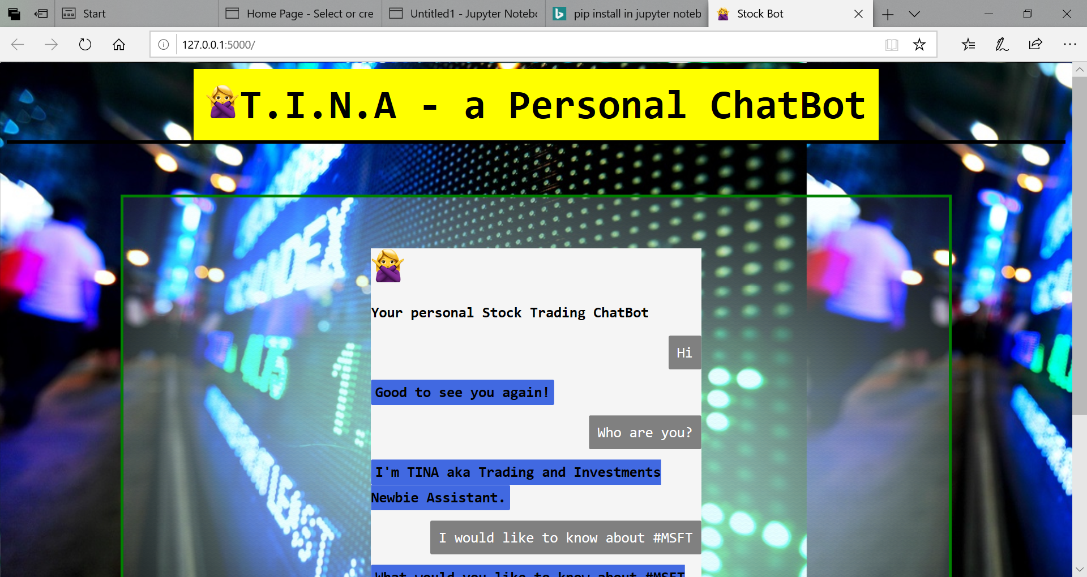

Figure 20: Chatbot interacting with user using ticker symbol

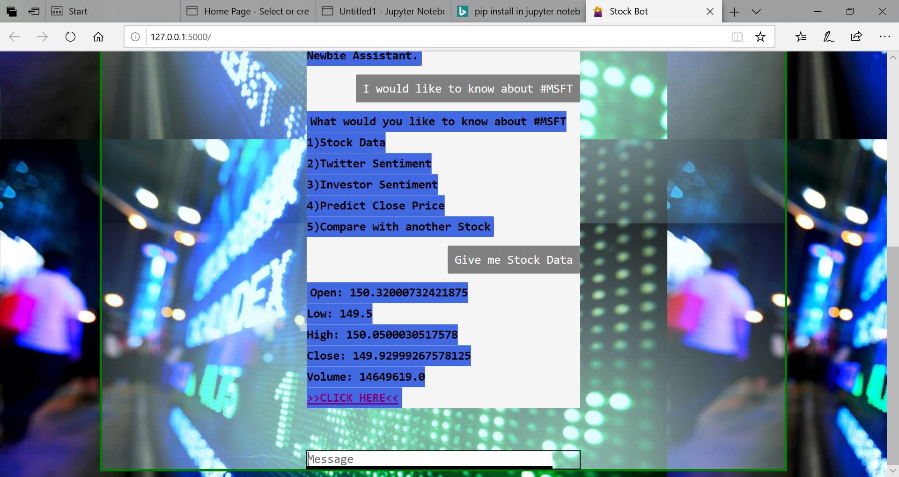

Figure 21:Chatbot Features and viewing historical data of stock

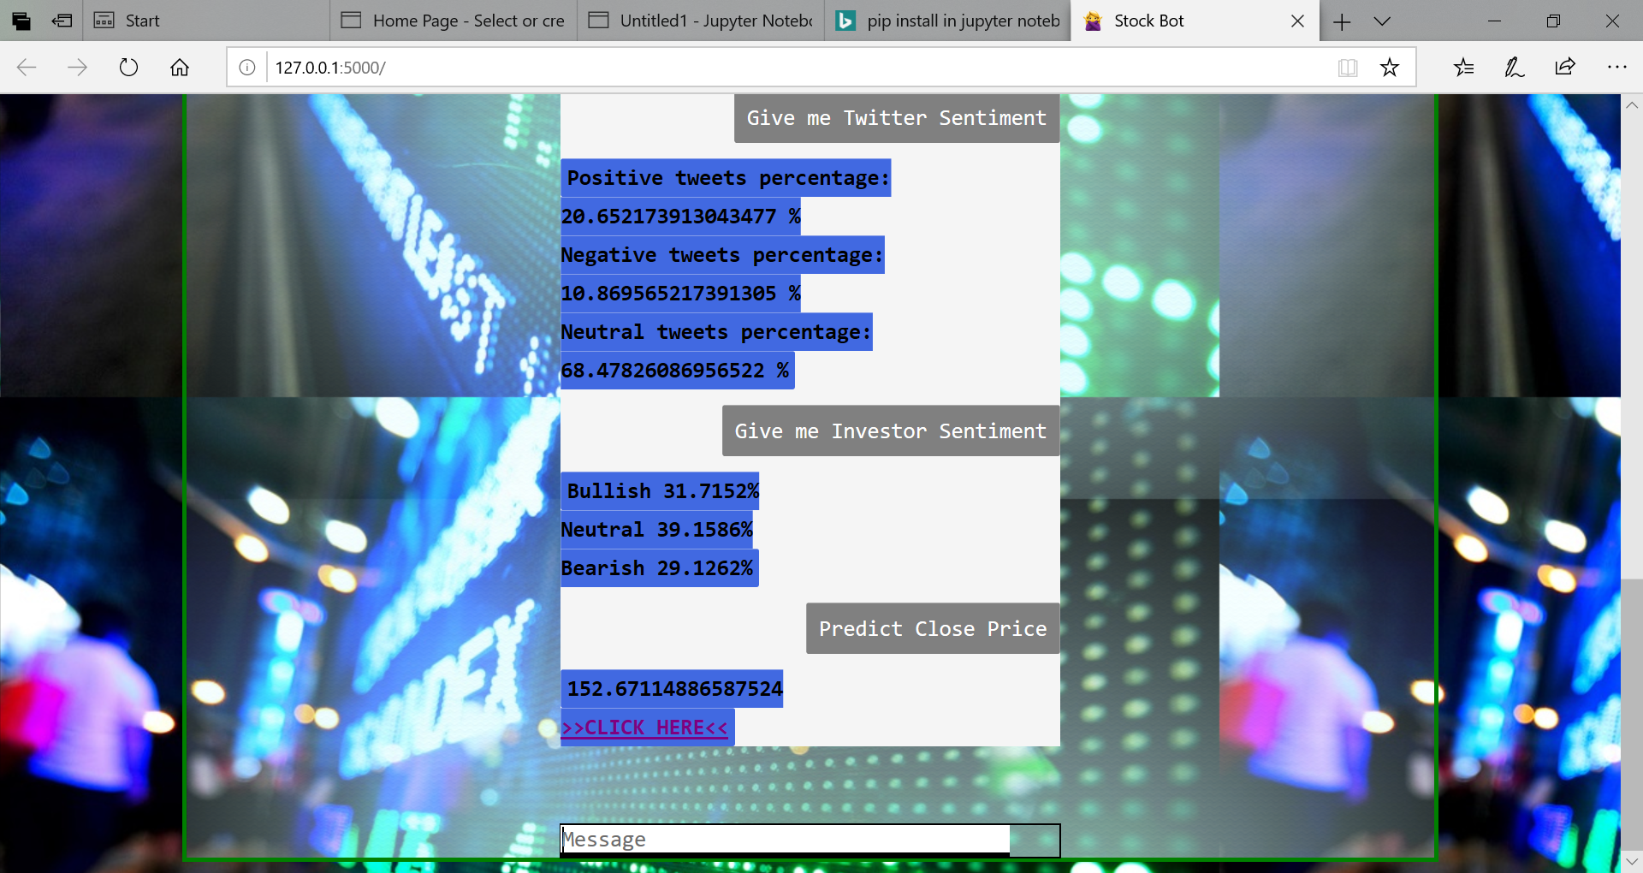

Figure 22: Chatbot displaying Investor sentiments and Predicted future closing price

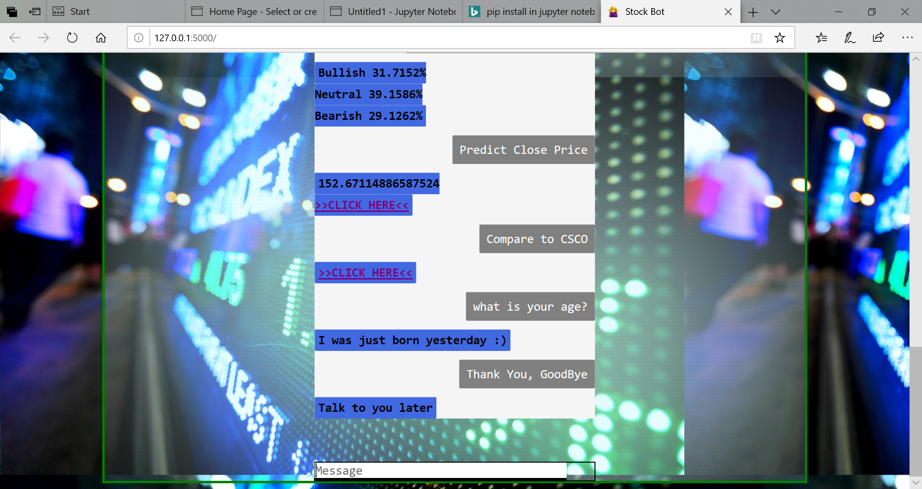

Figure 23: Chatbot displaying Comparison of stocks

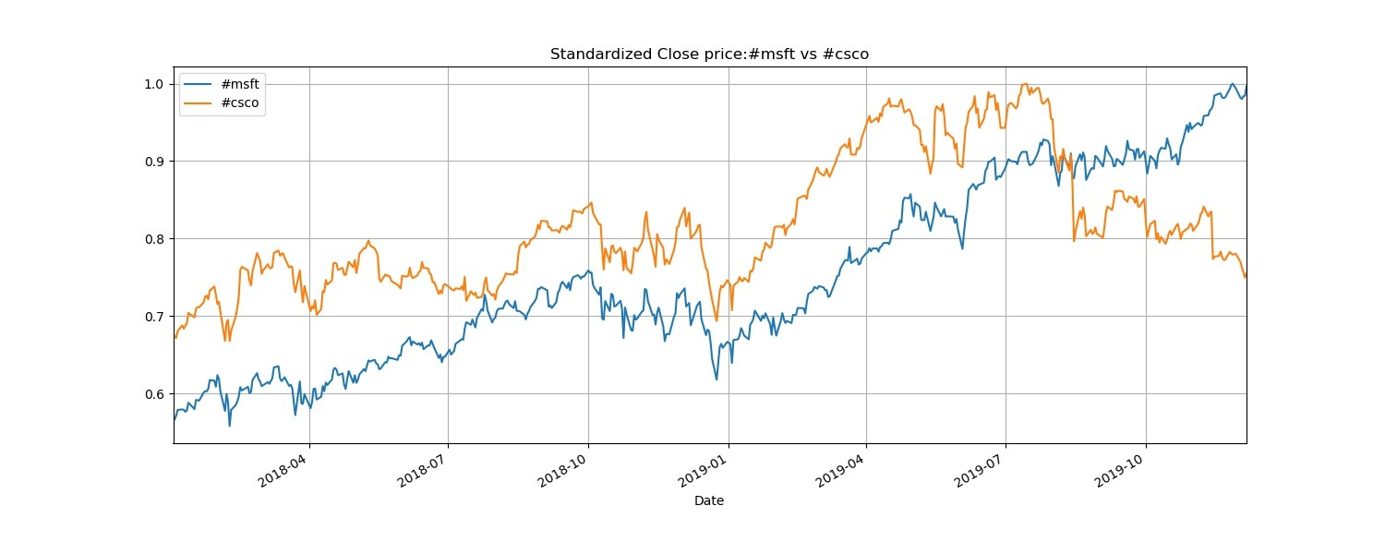

Figure 24: Comparison of two stocks

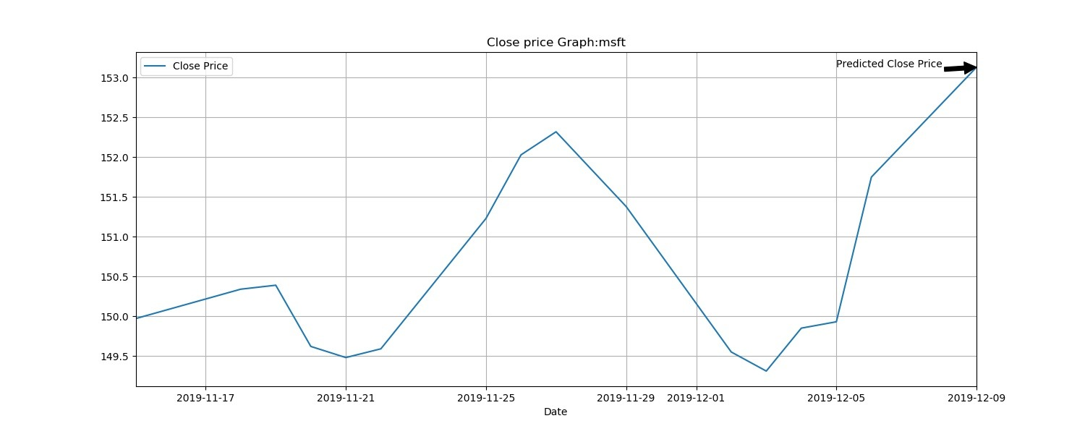

Figure 25: Predicting the future closing price of stock

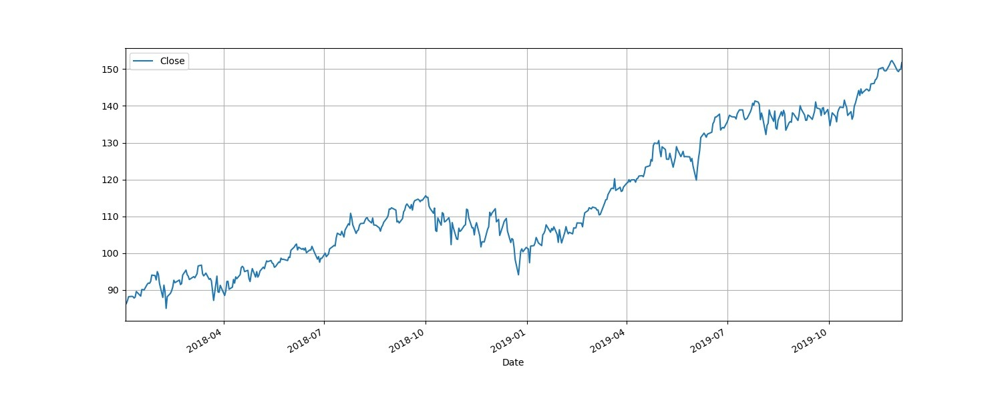

Figure 26: Graph showing the historical data

**Chapter 8**

# **Server-Side Design**

Trading and Investment Newbie Assistant (TINA) is a Personal Stock Bot powered by multiple Machine Learning models in the backend.

A Neural Network model is powering the chatbot application to classify the type of Intent class the Input belongs to.

LSTM model is used to prediction of the close price. We are using multiple LSTM models each trained for a specific company’s stock dataset. Currently, we have trained 5 models for 5 different companies.

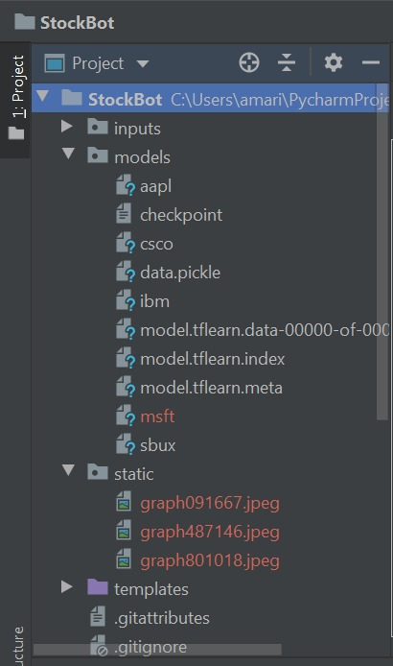

Figure 27: Server side

Once these models are trained, the best performing model is saved and whenever we want to predict the close price, we are preparing the input test dataset and are loading the saved model to predict the price. All these models are saved in models folder in the StockBot project.

**Chapter 9**

# **Model Deployment**

The libraries and resources which we used for deploying machine learning model for Trading and Investment Newbie Assistant (TINA) chatbot using python are:

**Pickle:** The best model for LSTM is saved using pickle file. It is a process wherein a python object is converted into a byte stream. Serializing is a way in which python object is written on a disk which can be transferred anywhere. The code created .pkl file which can be transferred anywhere [14].

**Flask:** It is easy to use, web application framework written in python. Packages for using flask were installed as **pip install flask flask_cors jsonify numpy pandas**

The steps followed are:

1. Model is trained using Google Colaboratory Environment (Python Integrated Development Environment (IDE)). Is based on Python Jupyter notebooks which gives the user free access to Tesla K80 GPUs. It provides the ability to experiment with deep learning. To access the environment, you must have a signed in Google Drive account.
2. The trained model object is saved using pickle (serialization) module in python.
3. flask-app was set over the localhost and default port (5000) and making the URL as <http://127>.0.0.1:5000/ shown in Figure 28 below



Figure 28: URL

The diagrammatic representation of the data flowing between the user and server space is shown in Figure 29 below [14]:

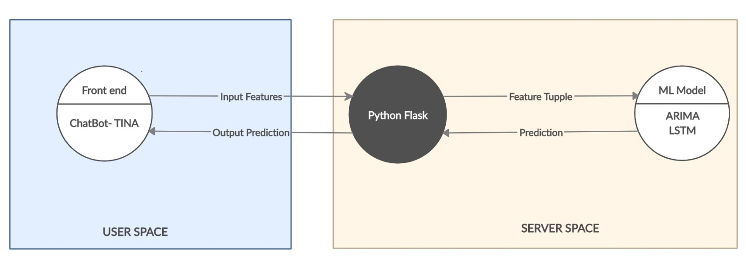

Figure 29: Data Flow between user and server space

The model data flow is illustrated in Figure 30 below:

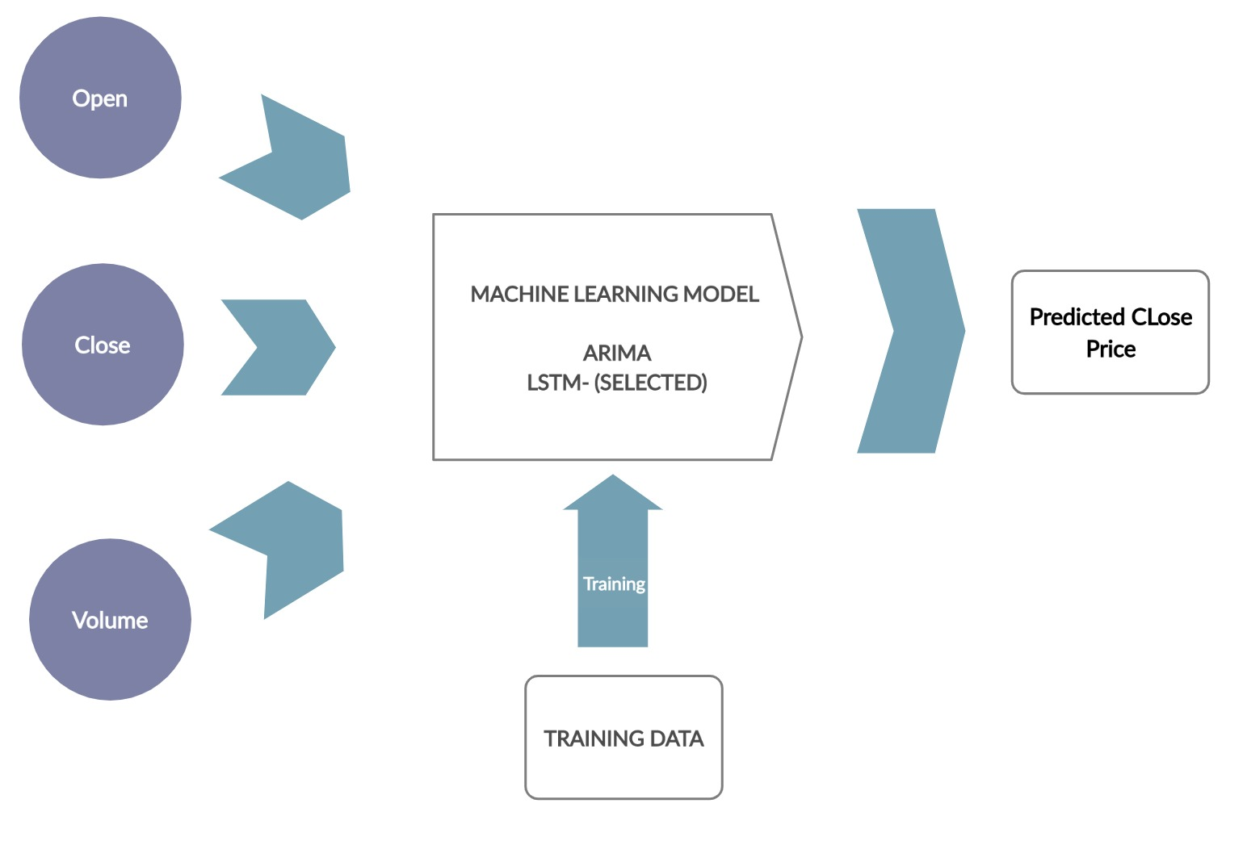

Figure 30: Model data flow

**Chapter 10**

# **Active Learning/ Feedback Loop**

While working on this project we enhanced our learning using following major learnings as mentioned in Table 3 below:

|  |  |
| --- | --- |
| Resource | Topic |
| Online Datacamp Courses | Time Series Analysis (ARIMA) |
| Websites, Medium Articles, GitHub | LSTM and ARIMA implementation |
| Class Room Lectures and Readings, Books | Data Mining Techniques |

Table 3: Learning Resources

These learnings helped in enhancement of technical and behavioral skills as below:

## **Technical Skills**

* Predicting accurate stock price is difficult as there are several factors which directly or indirectly influence the price of stock.
* Traditional ARIMA Model used in Time series analysis.
* Deep learning model LSTM used in Time series analysis.
* Generalizing LSTM
* Difference between LSTM and ARIMA.
* Sentiment analysis methods for analyzing top 200 tweets based on ticker symbol.
* Flask using Python
* Chatbot designing using Neural Networks

## **Behavioral skills**

* Resolving conflicts within Team
* Organizing and Planning skills
* Listening skills
* Being responsible
* Effectively Communicating ideas

**Chapter 11**

## **High Performance Computing (HPC)**

To run models effectively we can use Google Colaboratory Environment which provides users free access to use GPU and TPU for free. It is based on Python Jupyter notebooks which gives the user free access to Tesla K80 GPUs. It provides the ability to experiment with deep learning. The other technologies used are Cloud Computing technologies of Google Cloud Platform, Amazon Web Services and Microsoft Azure.

## **Google Cloud Platform**

It is public cloud computing services offered by Google which provides higher level services for big data and machine learning. It offers a Cloud Machine Learning engine for artificial intelligence, enabling users to build and train models using APIs available for the translation and analysis if speech, text, images and videos. [15]



Figure 31: High Performance computing technologies

**Chapter 12**

## **Design patterns**

The trading patterns followed as per previous works done related to this topic are:

1. **News Headlines:** The stock market movement can be determined by sentiment analysis on the news released on various sources like websites, newspapers etc. A negative news may result in stock price decrease and vice-versa.

2. **Technical indicators, such as momentum, volatility and moving averages, are applied to the data set.**

2.1 **Momentum**: It indicates the speed or velocity with which price changes. It is calculated for stock, index and sector. [16]

2.2 **Volatility**: volatility of a stock is the amount a stock is likely to move away from the

price at which it was traded at any given time. [17]

2.3 **Moving Averages**: It is a widely used indicator in technical analysis that helps smooth

out price action by filtering out the “noise” from random short-term price fluctuations. The commonly used are Simple and Exponential Moving Average. [18]

In Trading and Investment Newbie Assistant (TINA) we used historical data of 19 years and twitter tweets. Using historical data helps in understanding the pattern or trend of prices over a period of time and thus helps in predicting the future related value.

# **Bibliography**

|  |  |
| --- | --- |
| [1] | C. Watson and A. Donohoe, "6 Characteristics of Stock Markets," 28 January 2019. [Online]. Available: https://finance.zacks.com/6-characteristics-stock-markets-2511.html. |
| [2] | "Time Series Analysis and Forecast Service for Your Business," [Online]. Available: https://www.researchoptimus.com/article/what-is-time-series-analysis.php. |
| [3] | C. E. Sapp, "Preparing and Architecting for Machine Learning," Gartner Technical Professional Advice, 17 January 2017. |
| [4] | "Wrike Solutions," [Online]. Available: https://www.wrike.com/project-management-guide/faq/what-is-pert-in-project-management/. |
| [5] | O. Maimon and L. Rokach, "Introduction to Knowledge Discovery in Databases," in *Data Mining and Knowledge Discovery Handbook*, p. 17. |
| [6] | L. Buitinck, G. Louppe, M. Blondel, F. Pedregosa, A. Mueller, O. Grisel, V. Niculae, P. Prettenhofer, A. Gramfort, J. Grobler and R. Layto, "Design for machine learning software: experiences from the scikit-learn project," in *ECML PKDD Workshop: Languages for Data Mining and Machine Learning*, 2013, pp. 108--122. |
| [7] | A. Gupta, P. Bhatia, K. Dave and l. P. jain, "Stock market Prediction using Data Mining Techniques," in *2nd International Conference on Advances in Science & Technology (ICAST) 2019 by K J Somaiya Institute of Engineering & Information Technology*, Mumbai, India, 2019. |
| [8] | "What is Use Case Diagram?," Visual Paradigm, [Online]. Available: https://www.visual-paradigm.com/guide/uml-unified-modeling-language/what-is-use-case-diagram/. |
| [9] | A. Cockburn, "Use Cases: Defining scope," in *Writing effective Use Cases*, Pearson, 2002, p. 5. |
| [10] | "Introduction to Flask," [Online]. Available: https://pymbook.readthedocs.io/en/latest/flask.html. |
| [11] | J. Brownlee, "Machine Learning Mastery:How to Create an ARIMA Model for Time Series Forecasting in Python," 09 January 2017. [Online]. Available: https://machinelearningmastery.com/arima-for-time-series-forecasting-with-python/. |
| [12] | A. Deshpande, "Perform sentiment analysis with LSTMs, using TensorFlow," O Reilly, 13 July 2017. [Online]. Available: https://www.oreilly.com/learning/perform-sentiment-analysis-with-lstms-using-tensorflow. |
| [13] | A. Nayak, "Predicting Stock Price with LSTM," Medium: Towrads Data Science, [Online]. Available: https://towardsdatascience.com/predicting-stock-price-with-lstm-13af86a74944. |
| [14] | V. Kumar, "Deploy Machine Learning Models for Free," Analytics Vidhya, 2018 14 December. [Online]. Available: https://medium.com/analytics-vidhya/how-to-deploy-simple-machine-learning-models-for-free-56cdccc62b8d. |
| [15] | M. Rouse, "searchcloudcomputing," [Online]. Available: https://searchcloudcomputing.techtarget.com/definition/Google-Cloud-Platform. |
| [16] | T. Segal, "Understanding Momentum Indicators and RSI," 24 June 2019. [Online]. Available: https://www.investopedia.com/investing/momentum-and-relative-strength-index/. |
| [17] | WiseStockBuyer, "What are Volatile Stocks?," [Online]. Available: http://www.wisestockbuyer.com/what-are-volatile-stocks/. |
| [18] | A. Hayes, "Moving Average (MA)," 19 June 2019. [Online]. Available: https://www.investopedia.com/terms/m/movingaverage.asp. |
|  |  |